1. Write a program to calculate area and volume of sphere using static variable and method create two static methods for area and volume calculation. (insert data from user).

Program:

import java.util.Scanner;

class Sphere{

    static int numberOfSphere;

**Sphere**(){

*//Static variable*

        numberOfSphere++;

    }

    double **Area**(int *rad*){

        return 4*3.14*rad*rad;

    }

    double **Volume**(int *rad*){

        return 4*3.14*rad*rad*rad/3;

    }

*//Static Method*

    static int **numberOfSpheres**(){

        return numberOfSphere;

    }

}

public class Ass3_1 {

    public static void **main**(String[] *args*) {

        Scanner inp = new **Scanner**(System.in);

        Sphere S1 = new **Sphere**();

        System.out.**println**("Number of Sphere:"+S1.**numberOfSpheres**());

        System.out.**print**("Enter the radius:");

        int radius1 = inp.**nextInt**();

        double Area = S1.**Area**(radius1);

        double Volume = S1.**Volume**(radius1);

        System.out.**println**("Area of Sphere:"+Area);

        System.out.**println**("Volume of Sphere:"+Volume);

        Sphere S2 = new **Sphere**();

        System.out.**println**("Number of Sphere:"+S2.**numberOfSpheres**());

        System.out.**print**("Enter the radius:");

        radius1 = inp.**nextInt**();

        Area = S2.**Area**(radius1);

        Volume = S2.**Volume**(radius1);

        System.out.**println**("Area of Sphere:"+Area);

        System.out.**println**("Volume of Sphere:"+Volume);

    }

}

Output: 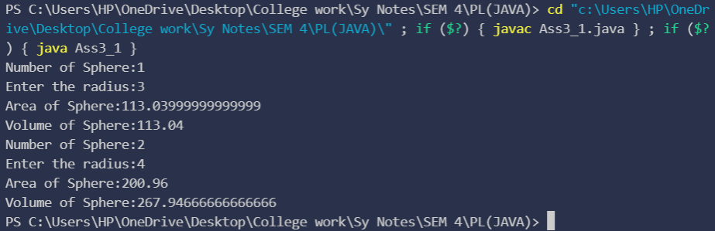

1. Display all your information (prn, name, age, address, class) on console without creating any object and writing any code in main method.

Program:

public class Ass3_2 {

    static{

        System.out.**println**("Prn No.: 2020BTECS00074");

        System.out.**println**("Name : Aman Agrawal");

        System.out.**println**("Age : 19");

        System.out.**println**("Address : Sphruti Chowk, Sangli-416415");

        System.out.**println**("Class : 2nd Year");

    }

}

Output: 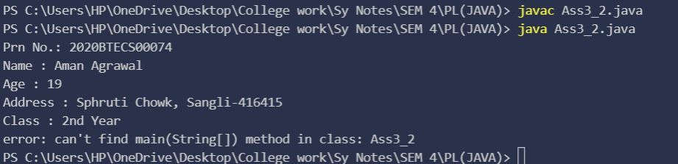

1. Demonstrate how to use static inner class and non-static inner class to access static and non-static members of outer class.

Program:

class Outer{

    static int n;

    int non=0;

    public static class StaticInner{

        static int noOfObject;

        static void **increase**(){

            n++;

            System.out.**println**("n = "+n);

            noOfObject++;

            System.out.**println**("no of Object = "+noOfObject);

        }

    }

    class Inner{

        int noOfObject=0;

        void **increase**(){

            non++;

            System.out.**println**("non="+non);

            noOfObject++;

            System.out.**println**("no. of Object = "+noOfObject);

        }

    }

}

public class Ass3_3{

    public static void **main**(String[] *args*){

        Outer out = new **Outer**();

        Outer.Inner obj1 = out.new **Inner**();

        Outer.StaticInner obj2 = new Outer.**StaticInner**();

        obj2.**increase**();

        obj1.**increase**();

*// obj1.increase();*

    }

}

Output: 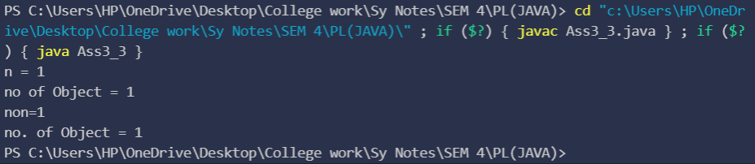

1. Write a program using final variable to check speed limit exceeds or not on highway. If speed is greater than 100. Then generate alert message.

Program:

import java.util.*;

public class Ass3_4 {

    public static void **main**(String[] *args*) {

        final int speedlimit = 100;

        Scanner sc = new **Scanner**(System.in);

        System.out.**print**("Enter the Speed:");

        int speed = sc.**nextInt**();

        if(speed>speedlimit){

            System.out.**println**("Speed Limit is Exceeded!!");

        }

    }

}

Output: 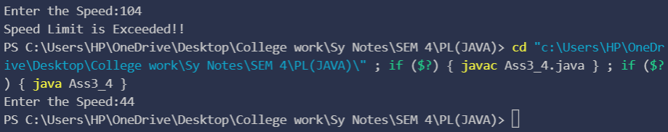

1. Create an abstract class 'Bank' with an abstract method 'getBalance'. $100,

$150 and $200 are deposited in banks A, B and C respectively. 'BankA', 'BankB' and 'BankC' are subclasses of class 'Bank', each having a method named 'getBalance'. Call this method by creating an object of each of the three classes.

Program:

abstract class Bank{

    abstract void **getBalance**();

}

class BankA extends Bank{

    int balance = 100;

    public void **getBalance**(){

        System.out.**println**("Balance in Bank A: "+balance+"$");

    }

}

class BankB extends Bank{

    int balance = 150;

    public void **getBalance**(){

        System.out.**println**("Balance in Bank A: "+balance+"$");

    }

}

class BankC extends Bank{

    int balance = 200;

    public void **getBalance**(){

        System.out.**println**("Balance in Bank A: "+balance+"$");

    }

}

public class Ass3_5{

    public static void **main**(String[] *args*) {

        BankA A = new **BankA**();

        A.**getBalance**();

        BankB B = new **BankB**();

        B.**getBalance**();

        BankC C = new **BankC**();

        C.**getBalance**();

    }

}

Output: 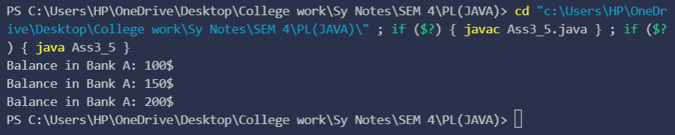

1. An abstract class has a construtor which prints "This is constructor of abstract class", an abstract method named 'a_method' and a non-abstract method which prints "This is a normal method of abstract class". A class 'SubClass' inherits the abstract class and has a method named 'a_method' which prints "This is abstract method". Now create an object of 'SubClass' and call the abstract method and the non-abstract method.

Program:

abstract class Abstracted{

**Abstracted**(){

        System.out.**println**("This is constructor of abstract class");

    }

    public abstract void **a_method**();

    public void **non_method**(){

        System.out.**println**("This is a normal method of abstract class");

    }

}

class SubClass extends Abstracted{

    public void **a_method**() {

        System.out.**println**("This is abstract method");

    }

}

public class Ass3_6 {

    public static void **main**(String[] *args*) {

        SubClass C = new **SubClass**();

        C.**non_method**();

        C.**a_method**();

    }

}

Output: 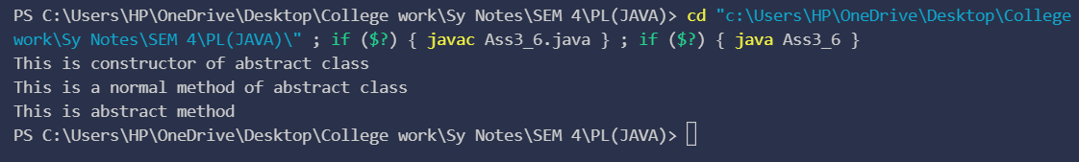

1. We have to calculate the area of a rectangle, a square and a circle. Create an abstract class 'Shape' with three abstract methods namely 'RectangleArea' taking two parameters, 'SquareArea' and 'CircleArea' taking one parameter each. The parameters of 'RectangleArea' are its length and breadth, that of 'SquareArea' is its side and that of 'CircleArea' is its radius. Now create another class 'Area' containing all the three methods 'RectangleArea', 'SquareArea' and 'CircleArea' for printing the area of rectangle, square and circle respectively. Create an object of class 'Area' and call all the three methods.

Program:

abstract class Shape{

    abstract void **RectangleArea**(int *length*,int *breadth*);

    abstract void **SquareArea**(int *side*);

    abstract void **CircleArea**(int *radius*);

}

class Area extends Shape{

    public void **RectangleArea**(int *length*,int *breadth*) {

        System.out.**println**("Area of Rectangle: "+ length*breadth);

    }

    public void **SquareArea**(int *side*) {

        System.out.**println**("Area of Square: "+ side*side);

    }

    public void **CircleArea**(int *radius*) {

        System.out.**println**("Area of Rectangle: "+ 3.14*radius*radius);

    }

}

public class Ass3_7 {

    public static void **main**(String[] *args*) {

        Area A = new **Area**();

        A.**RectangleArea**(4, 3);

        A.**SquareArea**(5);

        A.**CircleArea**(4);

    }

}

Output:

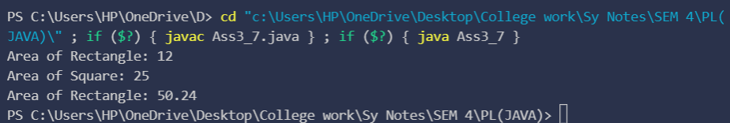

1. Define a package named ‘useful’ with a class name ‘Useme’ having following methods:
   1. area() → To calculate area of given shape.
   2. percentage() → to calculate percentage given total marks and marks obtained.

Develop a program to import above package and use both methods.

Program:

Package:

package useful;

import java.lang.*;

public class Useme{

    public double **area**(String *shape*, int *length*,int *breadth*) {

        if(shape == "Square"){

            return length*length;

        }

        else if(shape == "Rectangle"){

            return length*breadth;

        }

        else if(shape == "Circle"){

            return 3.14*length*length;

        }

        else if(shape == "Triangle"){

            return length*breadth/2;

        }

        else{

            System.out.**println**("Shape not listed in the function!!!");

            return 0;

        }

    }

    public float **percentage**(int *marks_obt*, int *total_marks*) {

        return marks_obt*100/total_marks;

    }

}

Main file:

import useful.*;

public class Ass3_8 {

    public static void **main**(String[] *args*) {

        Useme me = new **Useme**();

        double ar = me.**area**("Circle", 3, 0);

        System.out.**println**("Area of Circle="+ar);

        me.**area**("Trapezium",3,4);

        float percent = me.**percentage**(455, 480);

        System.out.**println**("Percentage = "+percent);

    }

}

Output:

